**Baku Higher Oil School**

**Process Automation Engineering Department**

**Programming in C**

**Laboratory 4 – Arrays**

**P.S** Add comment for each task; submit the file in LMS before the deadline.

1. Identify and correct the errors in each of the following. [Note: There may be more than one error in each piece of code.]
2. **#define SIZE 100**;
3. **SIZE** = **10**;
4. *Assume* **int** b[**10**] = { **0** }, i;

**For** (i = **0**; i <= **10**; ++i) {

b[i] = **1**;

}

1. **#include** <stdio.h>;
2. *Assume* **int** a[2][2] = { { 1, 2 }, { 3, 4 } };

a[**1**, **1**] = **5**;

1. **#define VALUE** = **120**
2. What does the following program do?

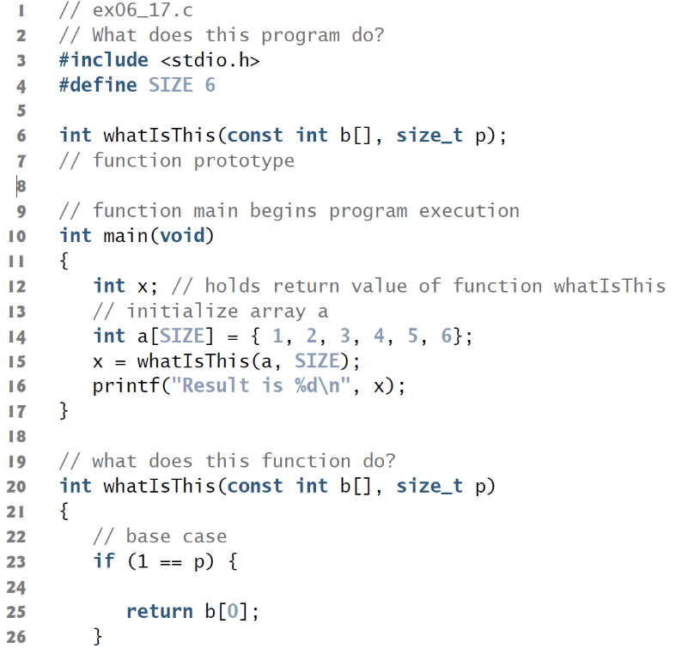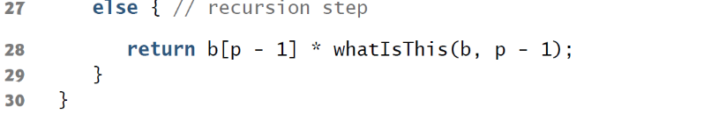

1. Write loops that perform each of the following one-dimensional array operations:
   1. Read the 20 elements of double array sales from the keyboard.
   2. Add 1000 to each of the 75 elements of double array allowance.
   3. Initialize the 50 elements of integer array numbers to zero.
   4. Print the 10 values of integer array GPA in column format.
2. Read n number of values and store in array. Print the array in reverse order.
3. Write a program to display the odd numbers of array (try with new array).
4. Write a function to find the minimum element in array.
5. Write a function to find the average of array.
6. Generate random values to store in 2D array size of 3x3 and print it in matrix form.
7. Find the maximum element of 2D array of size 3X2.
8. Find the sum of right diagonals of 2D array. The size of the square 2D array is 3.
9. Write a program to sum the 2 2D same size arrays.
10. Write a program to check whether a 2D array is identity array or not.
11. **(Intersection of Sets)** Use one-dimensional arrays to solve the following problem. Read in two sets of numbers, each having 10 numbers. After reading all values, display the unique elements common to both sets of numbers.
12. **(Recursive Exponentiation)** Write a function to calculate the standard deviation. Hint: set of number is a array. Use math library.
$$σ=\sqrt{\frac{\sum{{\left(x-μ\right)}^{2}}}{n}} \\ x is set of numbers; \\ μ is mean;μ=\frac{\sum{x}}{n} \\ n is the size of the set \\ σ is standart deviation$$

13. Create random value array and sort it with algorithms below:
    1. Bubble sort
    2. Selection sort
    3. Quick sort
14. Apply Binary Search to given array.